KASPER - ID 1

Software Development Team:

Gaurav Arora, Arianne Butler, Gong Cheng, Jeremy Liau, Haotian Ma, Christopher May, Kristof Mercier, Christopher Mykota-Reid, Tushita Patel, Dylan Prefontaine, Ryan Tetland, and Melody Zhao

Contents

Requirements - ID 2 3

Platform Description (iOS, Android, and Web Browser) 3

GUI Mock Ups: 4

Sequence Flow Diagrams: 6

Design 8

Smoke Test Status 8

Mini Milestones 8

Risk Report 8

Activity Log 8

Inspections Report 8

Client Meetings 8

Testing Results and Defect Reports 8

ID 3 Upcoming Requirements (remove all that are done for ID2) 9

User Requirements: 9

System Requirements 10

Future Requirements 10

Nice to Haves 10

Requirements - ID 2

* Basic User Interface
  + Buttons
  + Text boxes
  + Menus L
  + Links between screens
  + Swipe feature
* Generate Dummy Data Structures
  + User Structure:
    - Username
    - First Name
    - Last Name
    - Phone Number
    - Email Address
    - Password
    - City/Town
    - Listings List
  + Property Structure Fields:
    - City/Town
    - Address
    - Price
    - Square Feet
    - Bedrooms
    - Bathrooms
    - Description
    - Image List

## Platform Description (iOS, Android, and Web Browser)

* Insert Platform Description

## GUI Mock Ups:

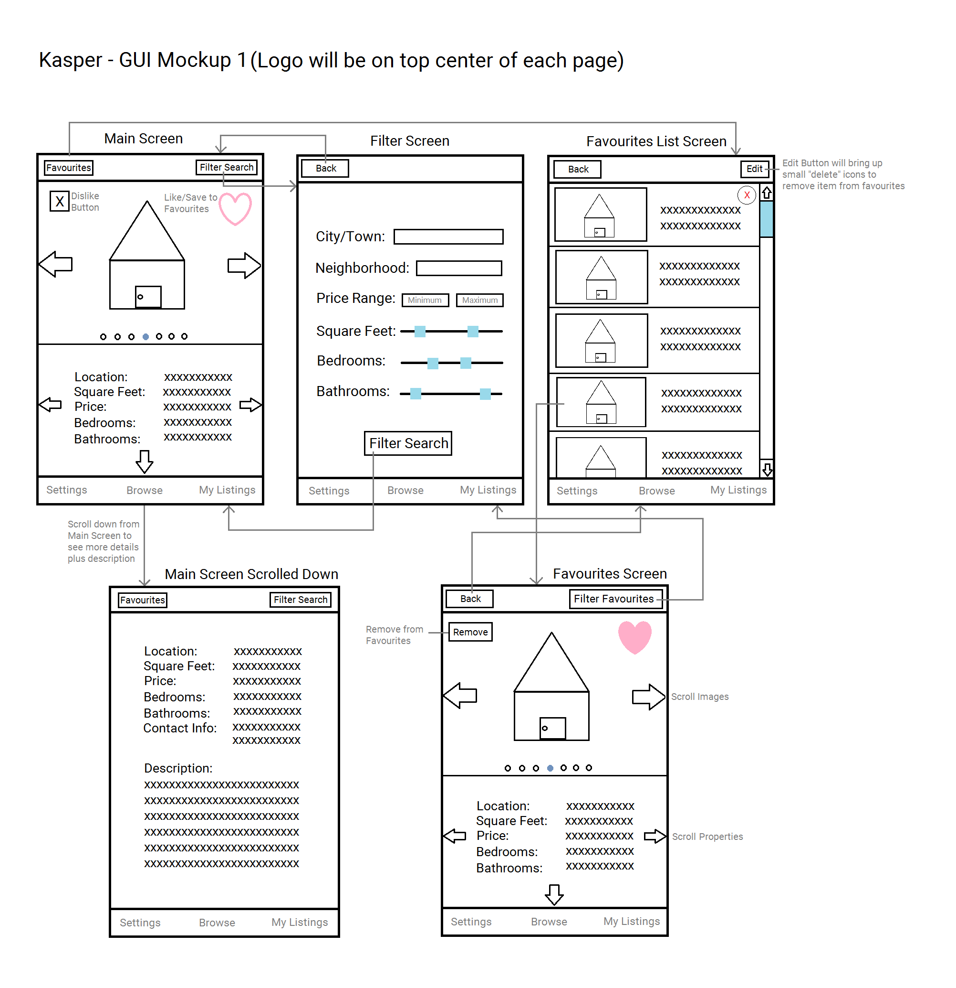

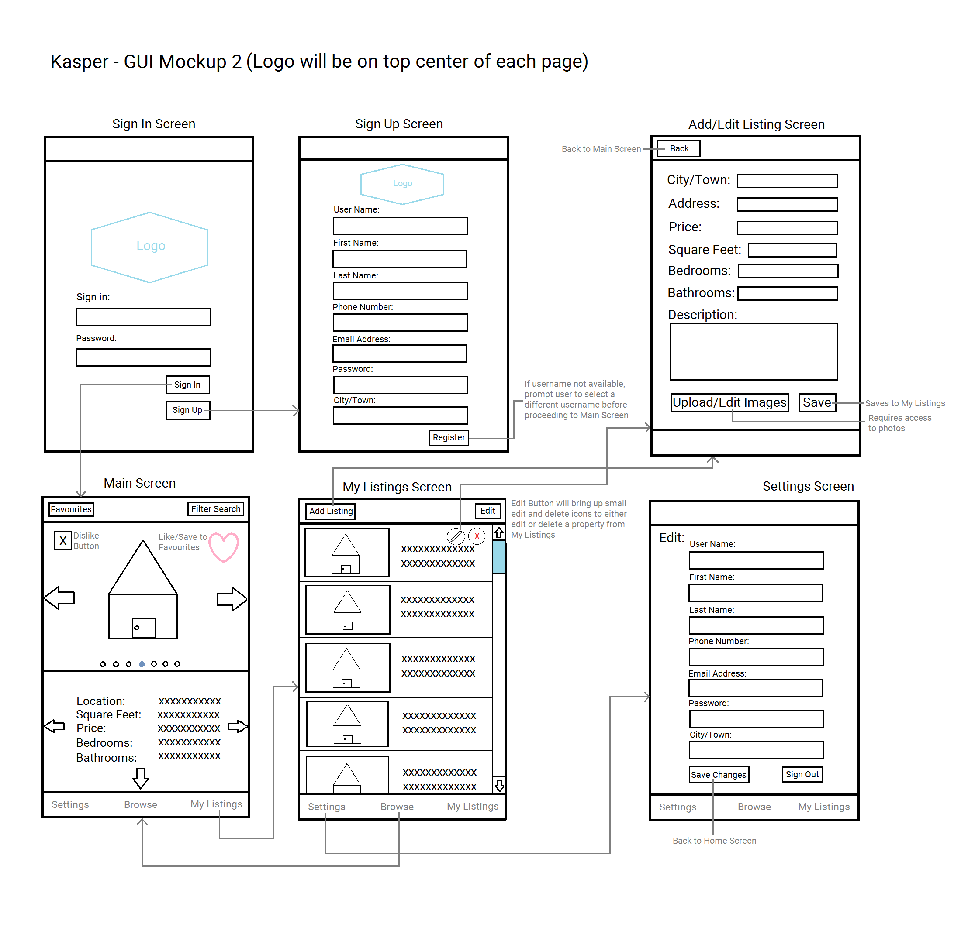

## Sequence Flow Diagrams:

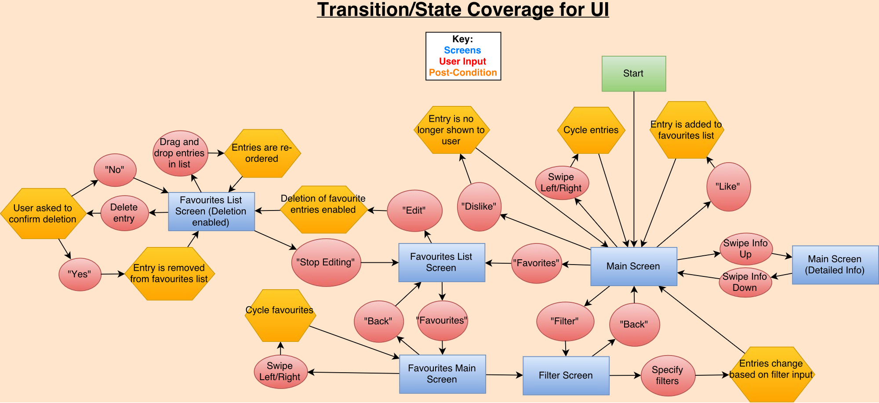

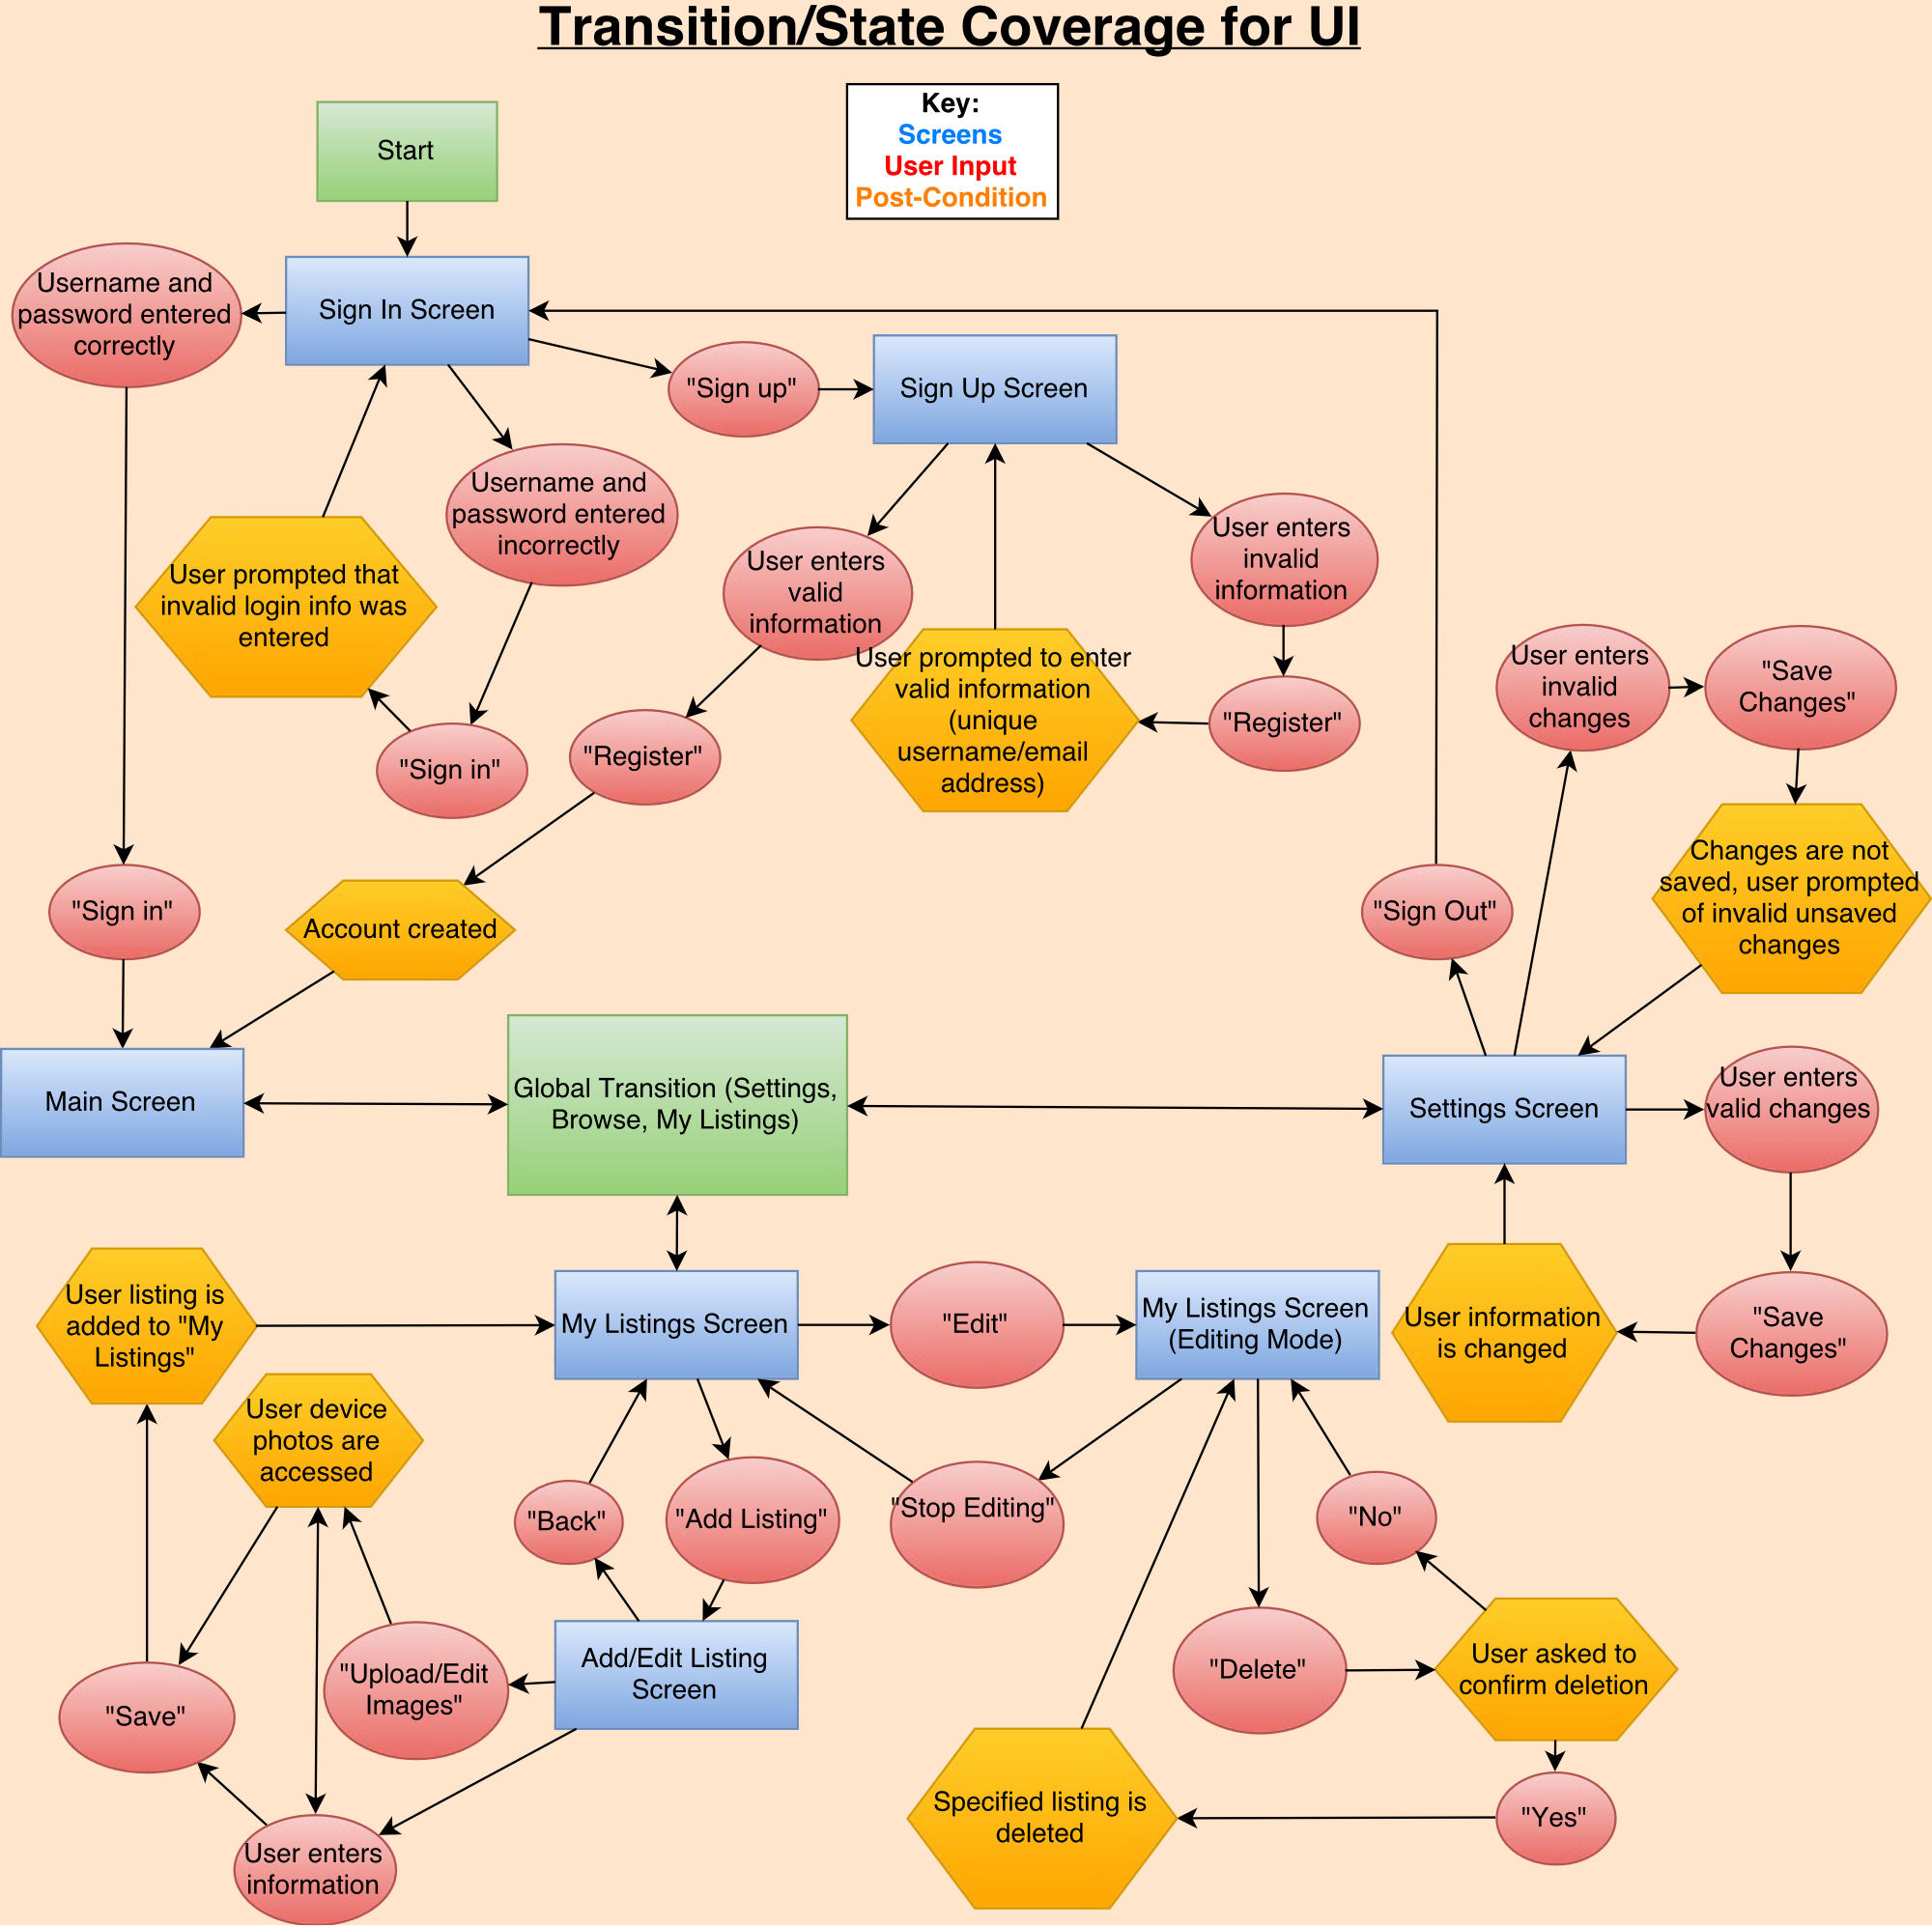

# Design

# Smoke Test Status

# Mini Milestones

# Risk Report

# Activity Log

# Inspections Report

# Client Meetings

# Testing Results and Defect Reports

# ID 3 Upcoming Requirements (remove all that are done for ID2)

## User Requirements:

General User Requirements:

* Log on
* Sign up
* Edit settings and User Info
* View all property listings

Buyer Specific Requirements:

* Filter Search Based on:
  + City/Town
  + Address
  + Category (house, condo, building, etc.)
  + Square Feet
  + Price range
  + Number of bedrooms
  + Number of bathrooms
* View all Listing Info (including pictures, descriptions, and seller contact info)
* Save Listing to Favourites
* Browse Favourites
* Remove Listing from Favourites
* Receive notifications regarding Favourites
  + Price changes
  + Listing removed/edited

Seller Specific Requirements:

* View personal listings
* Edit personal listings (text fields, description, and images)
* Add new listings (contact info can be automatically added via sign-up info)
  + Upload images
  + Input:
    - City/Town
    - Address
    - Category (house, condo, building, etc.)
    - Square Feet
    - Price
    - Number of bedrooms
    - Number of bathrooms
* Remove Listings

Super admin user:

* Log in as Super Admin
* Add new listing under any user
* Edit any listing
* Remove any listing

## System Requirements

* SSL certificate
* Server for data storage
* Domain access

# Future Requirements (Nice to Haves)

* Book a viewing feature
* Sign in using Facebook feature
* Set price watch on a given Listing
* Users can sign up to receive “hot list” notifications
  + Feature Listings (paid for by Sellers)
  + Newly added Listings
  + Price changes on Favourites
  + Based on previous search history
* Push notifications if something changes regarding a Listing saved in Favourites (change in database triggers notification)
* Sellers receive notifications regarding personal listings:
  + When a listing is saved to Favourites
  + When someone requests a viewing
  + When someone sets a price watch
* Integration with Google Maps